**D1 – Justify the inclusion of routine performance management activities within a network manager’s role**

**Introduction**

In this report, I will justify the role of a network manager. They have routines for the network and I will analyse the performance of the network and its activities they have.

A network manager’s role is to be responsible for installing and maintaining a network. As he/she is a manager, he/she need another role he needs to take care of. This is to keep track or train his/her employees. Each manager’s team will work as a team. The manager tells the other people what to do. He needs to do specific things to keep the team running and the network. Any manager would face problems within their role. They need to detect it and take time to erase the error. Breaking down one problem could potentially erase other potential and current errors that they are on the network. As any other network manager, you need to break down the each task for it to be complete. The routine of erasing errors is very important for the whole network. If not taken seriously, it could damage the whole network. If one computer is infected with viruses, it could spread, just like a disease. As it could spread, it can affect other computers on the network. This could potentially ruin the network. By doing this, daily routine checks on each workstation, the user can keep the network running. To do this, the user needs to run the performance and any anti-virus scan to avoid this, However, the manager cannot do this alone. He needs his technician and any other employees that are used for this to check the workstations. Scheduling the timing of this daily run is important. If any person is busy with another issue or role in the network, the technician could miss out something. It is important all of those to participate in the performance run to be on time, and not put all the pressure on the manager by expecting him to do it. By dividing the work between his/her team, it would be equal and less stress for the particular person. To conclude this, the network manager must work as a team and equal each task to his/her team.

**Tools**

To make it easier for every team in a network, the network manager can get softwares that can help you out for the easier tasks. All you have to do is run it, and it can get out any unnecessary files that you do not need for it. You can also use Cisco works, which designs and manufactures equipment within the network.

**-Cisco works**

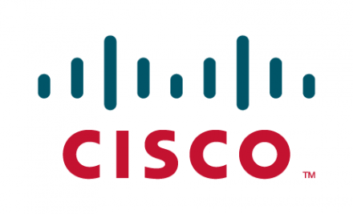This American company works its way round and designs, manufactures and sells managing network equipment. Each ‘cisco’ has its own equipment to deal with and today, cisco works deals with routers. Cisco works has an LAN management solution that is a web-based suite of tools developed in java by Cisco Systems. The main purpose of using this works is to use the anti-virus that is installed on the system to block any intruders entering the network. This is important, as many people will try to enter the network. This will to stop any person trying it.

**-Wire shark**

The purpose of Wire shark is a software that is used for network troubleshooting, analysis of the network and the communicating of the protocol. This is a network protocol that is used by companies. Wire shark will act like an anti-virus and if any nothing that Wire shark thinks it is appropriate for the computer, it will detect and remove it. Therefore, it acts like a protector but does the job of a network as well. Originally, the name was Ethereal, but in 2006, they renamed it. Wireshark has a number of features to display its network features. Any user can browse this program and download it of its original page.



**User Response Time**

This is how long the user takes to tell a technician that there is a problem with their computer, and the slower they tell them, the slower the problem will be resolved. In addition, the faster they tell them, the less problem. This is all about the response time. The longer the user takes time to tell the technician, the result could be massive. For example, if a virus is on the computer, it could potentially harm the system/network dramatically and quickly. The user needs to detect that is has a virus and needs to tell an IT expert what to do. They will advise them and it would be all sorted out. This is going to be used within a network by how long a technician will take. As stated before, depending on how long the technician takes, it will be resulted in the network being disrupted or not. Using this within a network has many benefits to it. By using this, it could solve many problems and any potential problems. User Response Time can be used in a network. It is important to be used within a network. They are many benefits for it to be used within an organisation.

In any organisation, they will be problems within the network.